|  |  |
| --- | --- |
|  |  |
| RESTAURANT LOCATION FINDER IN NORTH-CENTRAL KENT REGION |  |
|  |  |
|  | Maulik Patel |
|  | 27 May 2020 |

Table of Contents

RESTAURANT LOCATION FINDER IN NORTH-CENTRAL KENT REGION 1

Maulik Patel 1

27 May 2020 1

BACKGROUND 3

PROBLEM DESCRIPTION 4

DATA DESCRIPTION 4

SCOPE / INTEREST 4

DATA ACQUISITION 5

DATA WRANGLING 5

EXPLORATORY DATA ANALYSIS 6

CLUSTERING MODEL ( K-MEANS ) 8

CONCLUSION 12

FUTURE IMPROVEMENTS 12

ACKNOWLEDGEMENT 13

APPENDIX 14

REFERENCES 15

|  |  |  |  |
| --- | --- | --- | --- |
|  |  |  |  |
|  | BACKGROUNDChoosing a location for any business (new or expanding) is one of the crucial consideration and decision for its success. Make a mistake here and get ready to pay a hefty penalty either in terms of cost or time or both! | |  |
|  | Coming up with the mental image of the location for the business is sometimes cumbersome and complex piece of puzzle to solve.  Several factors play a vital role in deciding the appropriate location. Some of them are mentioned below:     * Demographics * Popularity * Accessibility * Competition * Cost * Security * Potential for Growth * Ordinances   Fortunately, with the help of Data Science Methodology, we can systematically and rationally provide answers and justification to most of the above factors increasing the probability of business success. |  |  |

### PROBLEM DESCRIPTION

This report particularly focuses on the Data Science principles to address the questions that arise from various factors (as mentioned in the background section) to select the location for a **Restaurant** business in **North-Central Kent Area.**

North-Central Part of Kent county comprises of 20 postcode districts in South East England (United Kingdom). It covers borough of Swale, Maidstone, Tonbridge and Malling, and Gravesham. It also includes Medway unitary authority.

Our goal is to find suitable location for opening a new Restaurant such that it increases chances of success by providing rationale and justification to all the crucial factors related to selection.

### DATA DESCRIPTION

The methodology applied here, uses the following location data:

|  |  |  |
| --- | --- | --- |
| **Data / Features** | **Source** | **Reference** |
| Town, Post code, Coverage, Local Authority | Wikipedia | https://en.wikipedia.org/wiki/ME_postcode_area |
| Latitude and Longitude information | ArcGIS API | https://en.wikipedia.org/wiki/ME_postcode_area |
| All nearby Venues information – Venue Name, Category, Latitude and Longitude | Four-Square API | https://developer.foursquare.com/docs/api-reference/venues/search/ |

### SCOPE / INTEREST

Even though the methodology applied here are to select best suitable Restaurant business location, its clustered data can be as input for most of the other business that intends to open a site or establishment in the defined area.

### DATA ACQUISITION

**Data Sources:**

In order to identify suitable location for our new restaurant site in the North-Central Kent county region of UK, we will need to analyse each town in the region.

* First, we identified all the Postcode districts in the Region. We captured this information from the Wikipedia (<https://en.wikipedia.org/wiki/ME_postcode_area>).
* Then we extracted exact location details(latitude and longitude) for town centre of each region using Arcgis API (<https://developers.arcgis.com/python/>).
* With the help of geographical coordinates, further information regarding venues and their details was obtained using the Foursquare Places API. (<http://developer.foursquare.com/docs/places-api/>)

### DATA WRANGLING

Importing the data set from Wikipedia, results in 4 tables out of which our table of interest is #2.

It contains location features such as Post code, Post town, Coverage and Local authority for 21 towns.

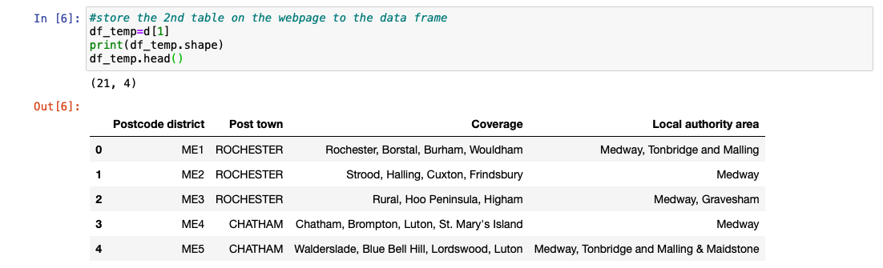

There also exists a non-geographic entry in the table which is irrelevant and hence need to be cleaned.



After removing non-geographic entry, the data frame(1) had 20 rows of 4 x features information.



In order to extract local venue information of each town, corresponding geographical coordinates are required for which Arcgis API is used.

So, after extracting latitude and longitude information for each row of our dataframe and appending it as extra features, it results as below.

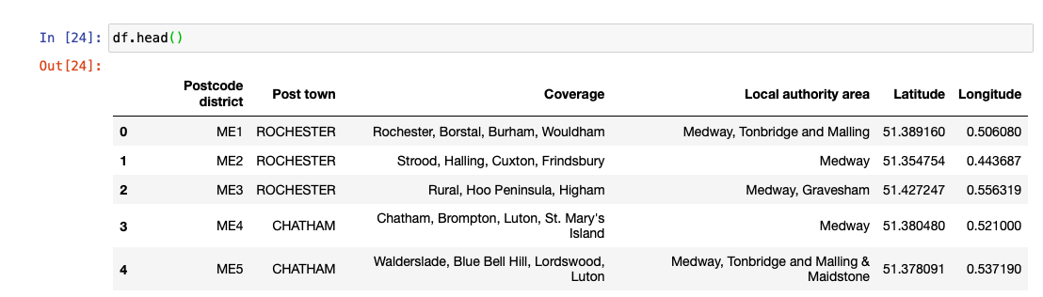

### EXPLORATORY DATA ANALYSIS

Additional data features required are the venue list, categories and location details for each town. FourSquare Places API (a [RESTful](https://en.wikipedia.org/wiki/Representational_state_transfer) API based on [HTTP](https://en.wikipedia.org/wiki/Hypertext_Transfer_Protocol) request and JSON response) is used for that purpose. All the venues data obtained by using this API will be used to cluster similar neighbourhoods, identify common restaurant locations and other hidden details which will then aid us in factoring out our new restaurant site.

Query for GET method of FourSquare Places API is created and all venue details are received in JSON format.

# create the API request URL

url = 'https://api.foursquare.com/v2/venues/explore?&client_id={}&client_secret={}&v={}&ll={},{}&radius={}&limit={}'.format(

CLIENT_ID, # Client ID

CLIENT_SECRET, # Client Secret

VERSION, # App Version

lat, # Latitude

lng, # Longitude

radius, # Radius

LIMIT) # Max number of venues

# make the GET request

results = requests.get(url).json()["response"]['groups'][0]['items']

Total number of venues found using API was **225.**

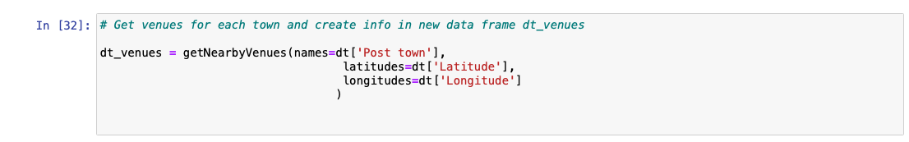



Further, number of venues per town was identified by grouping them as below.

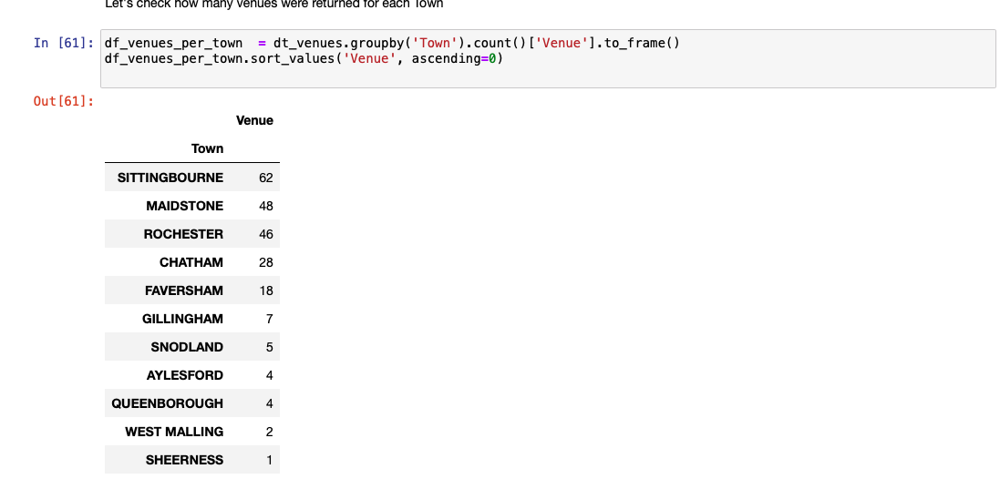

So, ***Sittingbourne****,* ***Maidstone*** and ***Rochester*** seemed to be highly popular for business and have considerable amount of already established business. Hence, these top 3 towns were further analysed.

The most common venues for these 3 towns were:

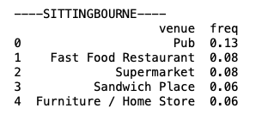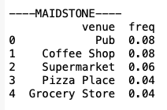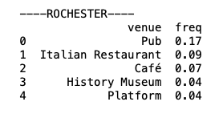

Since our target is to locate new restaurant site, aggregated frequency of related businesses (e.g. Pub, Restaurant, Coffee shop, Pizza place, etc.) for above towns were calculated.

|  |  |  |  |  |  |
| --- | --- | --- | --- | --- | --- |
| **Sittingbourne** | | **Maidstone** | | **Rochester** | |
| **Venue** | **Freq** | **Venue** | **Freq** | **Venue** | **Freq** |
| Pub | 0.13 | Pub | 0.08 | Pub | 0.17 |
| Fast Food Restaurant | 0.08 | Coffee Shop | 0.08 | Italian Restaurant | 0.09 |
| Sandwich Place | 0.06 | Pizza Place | 0.04 | Café | 0.07 |
| ***Aggregated Sum*** | ***0.27*** |  | ***0.2*** |  | ***0.33*** |

It is obvious from above findings that Rochester and Sittingbourne share distinct similarity in terms of their businesses’ characteristics. This brought end of our Exploratory Data Analysis. However, data was modelled and clustered as a next step, to shed more light on this.

### CLUSTERING MODEL ( K-MEANS )

**K-means** algorithm is an iterative algorithm that tries to partition the dataset into *K* pre-defined distinct non-overlapping subgroups (clusters) where each data point belongs to only one group. It tries to make the intra-cluster data points as similar as possible while also keeping the clusters as different (far) as possible. Further information on K-Means can be found [here](https://en.wikipedia.org/wiki/K-means_clustering).

Since our dataset include 20 towns of the region, the number of cluster formation selected was 5.

Selecting 5 clusters in our dataset of 20 towns, and applying K-means algorithm on the dataframe, we get below clusters:

Rochester, Sittingbourne and Maidstone (outcomes of our Exploratory Data Analysis) belong to same cluster which strengthens our justification.

So, then maps of Sittingbourne and Rochester were explored exclusively along with the venue details for these two towns as follows.

SITTINGBOURNE

ROCHESTER

Listing these towns’ venues alongside:

Inference drawn from map and listing:

**Sittingbourne:**

* Sittingbourne is typical town with Shopping Center with the traditional high street market and a train station in nearby vicinity.

**Rochester:**

* Rochester is Medway river side town with traditional high street market, and train station in nearby vicinity.
* Since it riverside town, it is more likely to have some pleasing riverside views.
* Further it has a Castle, Church, Marina, History Museum, Park and a Tourist Information Center.

### CONCLUSION

Complete Jupyter Notebook for this Data Science Project can be found by clicking [here](https://github.com/maulik82/Coursera_Capstone/blob/master/Project/Clustering-North-Central-Kent-Towns.ipynb).

Now Let’s recall some the crucial known factors mentioned in the introduction section for choosing a new business site which can be addressed by our methodology so far.

* *Demographics*

Being a Riverside town with probably pleasing views, Rochester holds the edge for this factor. It also has diverse attractions such as Castle, Cathedral, and Museum.

* *Popularity*

Presence of Tourist Information Center indicates Rochester is more popular attraction for visitors. Hence it likely to attract more and diverse group increasing the likelihood of more business.

* *Accessibility*

Both Sittingbourne and Rochester have train station in vicinity. They are also close to Dual Carriageway “A2” encouraging car drivers to visit them.

Clearly, in the North Central Kent area (which includes borough of Maidstone, Swale, Tonbridge, Gravesham and Medway Towns), **Rochester** is paving the way for our new business site and is highly recommended option for new restaurant site based on above justifications.

### FUTURE IMPROVEMENTS

More the data and research on particular business, higher the confidence and success rate of acheiving it. Business survey, market research reports, etc. For Rochester should be considered. These can address other crucial factors such as competition, Cost, Security, Ordinances, etc.

|  |  |  |  |
| --- | --- | --- | --- |
|  | ACKNOWLEDGEMENT I would like to thank deeply to the following persons and entities:   1. Entire team of Four Square Company ([www.foursquare.com](http://www.foursquare.com)) for allowing their hard earned venues data to be used for development purpose. 2. Entire team of Esri company ([www.esri.com](http://www.esri.com)) for providing the Arcgis API so that all the geographical coordinates to be usd. 3. Finally, a deep thank you to Alex Aklson, Joseph Santarcangelo, Rav Ahuja, Romeo Kienzler, Svetlana Levitan, Saeed Aghabozorgi, Polong Lin and all the IBM Data Science Certification Instructors for their tremendous efforts and educating me on the Data Science methods, Algorithms, Visualisation, and Application. | u |  |

|  |  |  |  |
| --- | --- | --- | --- |
|  | APPENDIX **Dataframe**: DataFrame is a 2-dimensional labelled data structure with columns of potentially different types. You can think of it like a spreadsheet or SQL table, or a dictionary object. (1) |  |  |

|  |  |  |  |
| --- | --- | --- | --- |
|  | REFERENCES  1. About Pandas:   <https://pandas.pydata.org/pandas-docs/stable/getting_started/dsintro.html>   1. Github Juypter Notebook link:   <https://github.com/maulik82/Coursera_Capstone/blob/master/Project/Clustering-North-Central-Kent-Towns.ipynb>   1. K-Means algorithm:   <https://en.wikipedia.org/wiki/K-means_clustering>   1. HTTP Protocol:   <https://en.wikipedia.org/wiki/Hypertext_Transfer_Protocol>   1. REST APIS:   <https://searchapparchitecture.techtarget.com/definition/RESTful-API>   1. Four Square Places API:   <https://developer.foursquare.com/docs/places-api/>   1. Arcgis API for python:   <https://developers.arcgis.com/python/> |  |  |

|  |  |  |
| --- | --- | --- |
|  |  |  |
| THE END |
|  |